FR. CONCEICAO RODRIGUES COLLEGE OF ENGINEERING

Department of Computer Engineering

Course, Subject & Experiment Details

|  |  |
| --- | --- |
| Assignment No: | 1 |
| Title: | Case Study – Credit Card Approval Prediction |
| Name of the Students: | Warren Fernandes (8940) Abhi Gupta (8944)  Vinyas Kulal (8949) Liny Mathew (8950) |
| Date of Performance: | 03/02/2023 |
| Date of Submission: | 05/03/2023 |

Evaluation:

|  |  |  |
| --- | --- | --- |
| Sr. No. | Rubric | Grade |
| 1 | On time submission/completion (2) |  |
| 2 | Preparedness (2) |  |
| 3 | Skill (4) |  |
| 4 | Output (2) |  |

Signature of the Teacher

**CREDIT CARD APPROVAL PREDICTION**

**Introduction**

The financial industry has been leveraging machine learning algorithms to automate decision-making processes, and credit card approval prediction is one such process. Financial institutions face the challenge of assessing an applicant's creditworthiness before approving a credit card. The traditional approach involves evaluating factors such as the applicant's credit history, income, and debt-to-income ratio. However, with the proliferation of machine learning algorithms, financial institutions can leverage credit card approval prediction models to make more informed decisions.

**Problem Statement**

The goal of this project is to build a credit card approval prediction model that accurately predicts whether an applicant will be approved or denied a credit card. The model will be based on a range of features such as the applicant's age, gender, income, employment status, credit score, and credit history. The primary aim is to create a model that can help financial institutions make more informed decisions about approving or denying credit card applications.

Credit card approval prediction models have become crucial in the financial industry as they can help mitigate the risks associated with lending credit cards. The model should be trained on a historical dataset of credit card applications and should use machine learning algorithms to identify patterns and correlations between the features and the target variable. The model should be able to accurately predict whether an applicant will be approved or denied a credit card.

The project will involve several challenges, such as preprocessing the dataset to remove any duplicates, missing values, or outliers. Additionally, categorical variables will need to be converted into numeric values using techniques such as one-hot encoding. Furthermore, the dataset will need to be transformed to create new features that are more informative for the credit card approval prediction model.

The project's success will depend on selecting the most appropriate machine learning algorithm for the model. Several algorithms will be evaluated based on their performance metrics such as accuracy, precision, recall, and F1-score. The best-performing model will be selected for deployment.

The credit card approval prediction model aims to help financial institutions make more informed decisions about approving or denying credit card applications. The model should accurately predict whether an applicant will be approved or denied a credit card based on a range of factors such as age, gender, income, employment status, credit score, and credit history. By leveraging machine learning algorithms, the financial industry can automate decision-making processes, reduce risk, and improve the customer experience.

|  |  |  |  |
| --- | --- | --- | --- |
| **application_record.csv** | | | |
| **Feature name** | **Explanation** | **Type** | **Remarks** |
| ID | Client number | Interval |  |
| CODE_GENDER | Gender | Nominal |  |
| FLAG_OWN_CAR | Is there a car | Nominal |  |
| FLAG_OWN_REALTY | Is there a property | Nominal |  |
| CNT_CHILDREN | Number of children | Ratio |  |
| AMT_INCOME_TOTAL | Annual income | Ratio |  |
| NAME_INCOME_TYPE | Income category | Nominal |  |
| NAME_EDUCATION_TYPE | Education level | Ordinal |  |
| NAME_FAMILY_STATUS | Marital status | Nominal |  |
| NAME_HOUSING_TYPE | Way of living | Nominal |  |
| DAYS_BIRTH | Birthday | Ratio | Count backwards from current day (0), -1 means yesterday |
| DAYS_EMPLOYED | Start date of employment | Interval | Count backwards from current day (0). |
| FLAG_MOBIL | Is there a mobile phone | Nominal |  |
| FLAG_WORK_PHONE | Is there a work phone | Nominal |  |
| FLAG_PHONE | Is there a phone | Nominal |  |
| FLAG_EMAIL | Is there an email | Nominal |  |
| OCCUPATION_TYPE | Occupation | Nominal |  |
| CNT_FAM_MEMBERS | Family size | Ratio |  |

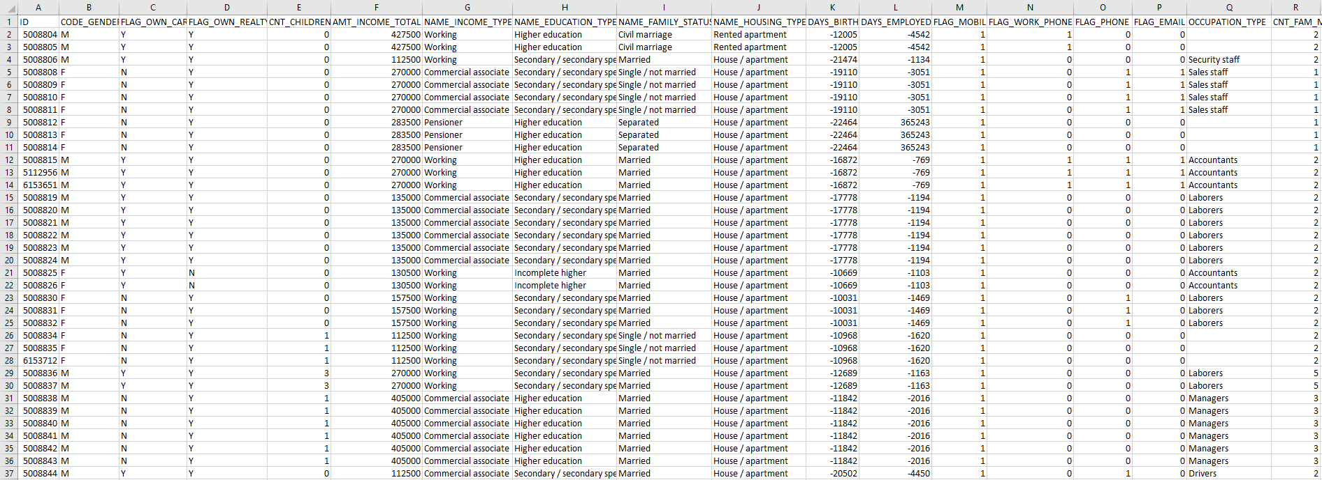

|  |  |  |  |
| --- | --- | --- | --- |
| **credit_record.csv** | | | |
| **Feature name** | **Explanation** | **Type** | **Remarks** |
| ID | Client number | Interval |  |
| MONTHS_BALANCE | Record month | Ratio | The month of the extracted data is the starting point, backwards, 0 is the current month, -1 is the previous month, and so on |
| STATUS | Status | Ordinal | 0: 1-29 days past due 1: 30-59 days past due 2: 60-89 days overdue 3: 90-119 days overdue 4: 120-149 days overdue 5: Overdue or bad debts, write-offs for more than 150 days C: paid off that month X: No loan for the month |

